**CHAPTER ONE**

1. **INTRODUCTION**

In this chapter, we have discussed background of the study, problems statement, significance, aim and objectives of the propose project. In addition, it also highlights the scope and limitations, methodology deployed in achieving the aim of the project, eventually we have provided the definition of some important terms used throughout in the project report.

* 1. **BACKGROUND OF THE STUDY**

Advent of information and communications technology (ICT) have completely transformed the ways in which data and information are created, structured, stored, transmitted or distributed, communicated and accessed. ICT has variety of importance and it impacted our daily activities tremendously, to the extent that cannot be separated from our daily lives. In this present era of information system, ICT has transform and ease the ways in which many management tasks are handled. It plays a vital and important role in solving human being’s problems at different organizational level and in our daily live activities. With ICT, the company can make the business easier and happier to execute with the client, supplier and the distributor.

The application of ICT technologies has surpassed industrials sector, but also extends to other sectors particularly educational sector. ICT technologies have provided many supports and facilities to enhance modern learning settings (Oliver, 2005). The use of ICT in educational sector, is not only limited to administrative task alone but also extend to teaching and learning perspective, like Management of “Student Industrial Working Experience Scheme (SIWES) task.

Furthermore, in this present difficult situation of world COVID-19 pandemic found ourselves, World Health Organization (WHO) advocate for physical distancing, therefore we need to automate and digitalize our learning activities, so as to maintain physical distancing in our learning process, being one of the major precaution guide given by health expert for safe guarding ourselves and prevent or minimized rapid spread of COVID-19 cases. Fortunately, existing of information communication and technology (ICT) has overcome the shortage of innovative technology for smoothly running teaching and learning activities without physical gathering. Thus several companies are coming up with new technologies to adjust old technologies in order to fit the reality of present situation.

Students’ Industrial Work Experience Scheme (SIWES) is a human capital formation program through industrial attachment for which students are expected to have a practical experience on the basis of theories and principles acquired in the teaching-learning process (Oyeniyi, 2012). In Nigeria, SIWES was introduced in the year 1973 to enable students in Universities, Polytechnics, Colleges of Technology, Colleges of Agriculture and Education to acquire practical skills needed to function satisfactorily in work-settings environment. It is a skills training programmed which affords students the opportunity of familiarizing, acquiring and exposing themselves with the needed experience in handling industrial equipment and machinery that are not usually available in their institutions. It is a Federal Government effort to bridge the discovered problem that students were graduating from their respective institutions with little or no technical knowledge or working experience.

Therefore, SIWES process requires a streamlined approach and constant monitoring to ensure that the desire objectives were achieve. Thus an online SIWES Management system was proposed in order to come up with an automated approach for which the manual task in performing the process will be eliminated so as to facilitate and makes the process more efficient.

* 1. **PROBLEM STATEMENT**

Currently, Federal University Dutse (FUD), operate a manual system for Managing SIWES programme activities. In which students have to visit SIWES coordinator’s office for the collection of siwes application latter and present it to the industry management for endorsement and return it back to the school SIWES coordinator. Upon submission of acceptance latter LOGBOOK and other necessary materials for recording daily learn activities are given to the students. Industry and lecturer supervisors need to make a comment in his logbook weekly and at the end of the programme respectively. School supervisor are assign and monitor by the SIWES coordinator. Thus absence of well-established automated SIWES system to serve computer science department has caused many inconveniences. This is basically because of the weakness of the existing system which includes over reliance on paper based work that consume a lot of the office space, slow recording, processing and retrieval of student’s details prone to human error especially when filling the logbook by student. In addition, there is a lot of stress on the personnel who are in charge of running the activities. To avoid these aforementioned drawbacks and make the system more efficient and accurately it need to be automated.

* 1. **AIM AND OBJECTIVES**
     1. **Aim**

The primary aim of this propose topic, is to design and implement a web-based Student’s Industrial Work Experience Scheme (SIWES) management system for Computer Science department, Federal University Dutse, that will automate, facilitate and enhance the manual process of carrying out SIWES activities.

* + 1. **Objectives:**

1. To enable school supervisor, monitor the progress of the student during their SIWES/IT programme.
2. To examine the current manual system in order to identify issues associated it.
3. To design and implement web-based system that will automate SIWES management process in Department of computer science Federal University Dutse (FUD).
4. To provide a user friendly interface system in which the entire system’s users can easily operate it.
5. To test and validate the system.
   1. **SIGNIFICANCE OF THE SYSTEM**

Currently, the faculty operates a manual SIWES Management system. Thus with introduction of this propose automated system the following benefits can be achieved:

1. **It saves time**: With this proposed system time-consuming would be reduce to a minimal level in the process of student assessment report.
2. **Speed**: with this proposed system processing of data will be very fast and delays can be avoided.
3. **Accuracy of the system**: Computer has the ability to produce correct or accurate result at all times provided the correct data is supplied. Thus developing this proposed automated system, the chances of making mistakes in the reporting process will remove or reduce.
4. **Security:** The system ensure that security is maintained by allowing lecturer, students and management personnel to login and access the system depending on their privileges. They are also able to work on the policies and claims more effectively and efficiently.
   1. **SCOPE AND LIMITATION**
      1. **Scope**

This proposed project is basically designed for Computer Science Department, Federal University Dutse (FUD). In the concept of system development many tools and techniques were used to develop the software according to given requirements. So HTML, PHP, JavaScript and CSS are the only language to be use in developing or implementing this propose system, in which the PHP embedded in HTML will serve as server side scripting combine with a client-site scripting language (JavaScript). CSS and HTML would be use to design a responsive and attractive graphical user interface (GUI). The database implementation will be achieve using MySQL database Management system while XAMPP will serve as local web server for testing or running the system prior to put into operation. In addition, only registered personnel can be able to login into and operate the system.

* + 1. **Limitation**

It is well-know that, every project work has it is own limitations, and the major limitations of this propose system are:

1. There is no provision to make online live communication like video or audio call between school/industry supervisor and students in the cause of complaint reporting.
2. The system cannot notify the school supervisor about punctual attendance of the students, this can be notifying only if industry based supervisor contact the supervisor through the system.
3. The system is not stand-alone so it will not operate in the absence of internet connectivity.
   1. **METHODOLOGY**

In order to achieve project’s aim and objectives proper and adequate strategy need to be deploy. Methods used or deployed in obtaining the required information and data related to the proposed project, includes review of several published research papers, magazines, journals articles and downloaded related document regarding SIWES Management system to enlighten and get broader view about the project’s requirements. In addition, survey which is one of the important methods used in quantitative research, was conducted in obtain the requirement of the proposed system.

* 1. **DEFINITION OF SOME TERMS**
     1. **DATABASE**: This is an organized collection of data file that services a variety of application in an organization.
     2. **PHP:** Hypertext preprocessor is a programing language used in coding server side.
     3. **ICT:** Information Communication and Technology.
     4. **MYSQL:** Which is a software serve as database.
     5. **CSS:** Cascading Style Sheet.
     6. **FUD:** Federal University Dutse.
     7. **GUI:** Graphical User Interface.
     8. **SIWES:** Student Industrial Work Experience Scheme.
     9. **HTML:** Hypertext Mark-Up Language.

**CHAPTER TWO**

**LITERATURE REVIEW**

**2.1 INTRODUCTION**

In this chapter of the project, we have discussed, the facts that initiates the idea of developing online SIWES Management system, role of information technology in the academic system and related works review regarding SIWES Management system were cited.

**2.2 FACT INITIATE CREATING OF ONLINE SIWES MANAGEMENT SYSTEM**

Internet has obviously transformed the face of the world, it makes sending and receiving information to and from others easily, without wasting much time compared to, when internet has not emerged. The Internetbeing worldwide collection of networks that connects millions of businesses, government agencies, educational institutions, and individuals (Discovering Computer fundamentals, 2011). More than one billion peoples around the world use the Internet daily for a variety of reasons, such as communication with other people, participation in online training and share information. According to (Adesanya, 2002) the internet is a global collection of many type of computers and computer network that are linked together. It is increasingly becoming the solution to many information exchange and management problems.

The advent of internet was really encouraging the initiating and development of almost online application in order to ease and turn things around. Thus gives and support the idea of developing online Student Industrial Working Experience Scheme (SIWES) Management system.

**2.2.1 Concept of Student’s Industrial Work Experience Scheme (SIWES)**

SIWES is a skills acquisition scheme, generally regarded as a cogent aspect of ratified least educational criterion in different programmes of study for obtaining degrees in Nigerian tertiary institutions (Onwuji, 2004, cited in Nse, 2012). SIWES is also consider as a human capital formation programme through industrial attachment for which students are expected to have a practical experience on the basis of theories and principles learned or acquired in the teaching learning process. In addition, among the importance of SIWES it exposed students to equipment, complex machines, professional work ethics and safety at place of work as well as workers in industrial settings (Onwuji, 2004, cited in Nse,2012).

Moreover, SIWES is also perceived as a three-way scheme which involves tertiary institutions/Universities, Polytechnics and Colleges of Education, and various companies/ organizations and students. The programme is fully funded by the Nigerian Government under her agencies, in which Industrial Training Fund (ITF), supervising the organizations such as: National Universities Commission (NUC); National Board of Technical Education (NBTE); and National Council for Colleges of Education (NCE) Mafe, (2010).



**Fig. 1.** Structure of SIWES in Nigerian Tertiary Institution (source: Researchers compilation, 2019)

**Table 1:** Tertiary Institutions, Duration of SIWES and No. of Programmes

|  |  |  |  |  |
| --- | --- | --- | --- | --- |
| **S/NO** | **Tertiary Institutions** | **Durations** | **Programmes** | **Source** |
| 1 | Students in Universities | 6 months | Sixty and above | Mafe, 2010 |
| 2 | Students in Polytechnics | 1 year | Forty and above | Mafe, 2010 |
| 3 | Students in College of Education | 6 months (teaching practice) | About ten programmes | Mafe, 2010 |

**Sources**: Researchers compilation, (2019).

**2.2.2 The Online SIWES Management System**

An online SIWES management system is a web-based system designed to support and improve the quality and accuracy of SIWES process. It also assists tertiary institution in compiling and or reporting student performance during IT programme and making work lesser for the management. It provides the ability for users to communicate easily (Stiles and Craig, 2007). It authenticates users to control who access what via student registration number and password. In addition, it enables the concurrent access (access by many users at a time) and facilitate the manipulation of data in faster rate. The online SIWES system can be access through the use of personal computer (PC), laptop or any smart phone devices connected to the internet.

**2.2.3 Benefits**

Online SIWES management system provides new functionalities and benefits over the current manual system in use. Manpower which has been traditionally used in monitoring and supervision of student during the programme can be reduce and perform efficient operation. By adopting innovative idea of this particular project, Institution can now be able to provide the convenience and efficient response as per as SIWES Management activities is concerned. In addition, it eliminates travelling and queuing of students during acceptance, submission of their application and acceptance letter respectively at initial stage and logbook eventually.

**2.3 ROLE OF INFORMATION TECHNOLOGY IN ACADEMIC SYSTEM**

Information technology (IT) has been an integral part of academic system, since some years before. According to Hewlet (1993) the world is entering an era in which technology will literally transform every aspect of business, life and society. Since the advent of internet technology, school system has been in transformation by taking the advantage of it, in making good use of it. Taylor (1980) says that computer base education includes both computer-assisted instruction programs that interact with students in a dialogue and a broader array of educational computer applications such as simulations or instructions in computer programming. Learning from a student bedroom, office or anywhere in the world has made its way into university system with the advent of internet technology. Thus information technology will facilitate managing of SIWES activities where by student obtains his/her application letter without carrying files around. Through the internet, this process is made much easier and sometimes the approval is made within seconds.

**2.4 REVIEW OF RELATED WORKS**

Several works related to SIWES Management system were reviewed, and among the reviewed works are e-SIWES Portal which was developed by Emmanuel Adetiba and Victor Matthew (2012), for Covenant University, online SIWES management system which was developed by A Emeka (2015) the system is a web-based developed using PHP, HTML, CSS and JavaScript, it is aim is to automate all the manual process in used for carrying out SIWES activities. E-SIWES Management system is a mobile-based application and developed using java, XML and PHP, and it is aim is to reduce Management’s overhead in discharging their duty. In similar manner, Buhari H. Rano and Shamsudden H. Muhammad (2017) developed online SIWES management system as final year project using PHP, JAVASCRIPT, CSS, APACHE and MySQL for the database. The above system was able to process data with great speed and also replaces the error-prone of manual system. With the objectives of providing reliable and transparent system to eliminate the problems associated with existing system.

Adetiba (2012) summarizes the advantages of online SIWES Management system to include the following:

1. It saves a lot of time.
2. . Information processing is very fast and delay can be avoided.
3. It is inexpensive to students and school management.

**Table 2 Comparison of the related system reviewed**

|  |  |  |  |
| --- | --- | --- | --- |
| **YEAR** | **TITLE** | **ACHIVEMENTS** | **GAPS** |
| 2012 | e-SIWES Portal for Covenant University designed and developed by Emmanuel Adetiba, Victor Matthew | It automate the manual process and enhance the task carrying out such as online supervisor assessment for both lecturer and industry supervisor, filling of logbook and dissemination of information | The design GUI is not friendly for users, as some of the importance function are not responding upon clicking. |
| 2015 | Online Siwes Management System developed by A. Emeka | It also automates the manual process in use. It enable the students, Industries and school supervisor to write learned experience and comments in logbook respectively. | It just transforms traditional manual SIWES system and makes it online, the system does not provide room for online submission of acceptance letter every student have to meet coordinator physically for submission. |
| 2017 | SIWES Management system: Web Technology Approach Case study faculty of computer science and information technology developed by Buhari H. Rano, Shamsudden H. Muhammad | It facilitates and simplify the process of SIWES management. The system provide a unique advantage of recommending a SIWES place to student | The developed system does not provide a communication panel between student, industry and school supervisor, to ease communication between the users. |
| 2019 | Design and Implementation of Mobile-base E-SIWES Management system | The developed system is a mobile-base application it make the system more portable being developed as android application. | Absent of function to enable online submission of acceptance latter, approved by the industries. |
| 2020 | Online SIWES Management Information Management System A Case Study of Akwa-Ibom State Polythicnics, Ikot Osurua. | The developed system it facilitate record manipulation by the administrators in charge | The system does not provide a room for recommending a SIWES place to any students. |

**CHAPTER THREE**

**SYSTEM ANALYSIS AND DESIGN**

**3.1 INTRODUCTION**

In this chapter of the project, we discussed about system analysis and design technique carried out in order to achieve the aim and objectives of the project. Furthermore, it contains the description, problems or drawbacks of the current (existing) system as well as advantages of the propose system. Software development life cycle (SDLC) model, functional, non-functional requirement, system specification and database design of the proposed system were also discussed.

**3.2 SYSTEM ANALYSIS**

Systems analysis is a problem-solving method that involves looking at the wider system, breaking it apart and figuring out how it works in order to achieve a particular goal ([www.study.com](http://www.study.com)). System analysis is also referring to as process of examining a system situation with the intent to improve it through better procedures and methods. In addition, system analysis involves studying of the current or existing system, to understand how operational data gathered and processed, decides whether the proposed system is desirable or not and whether there is the need to improve the existing system.

The basic aim of this project’s section is to examine the existing (current) system of Student Industrial Working Experience Scheme (SIWES) use in Federal University Dutse (FUD) in order to find out the drawbacks and come-up with solutions, which would give several benefits that will help, in improving and facilitate the existing system. It also provides the means of gathering all the requirements which are require for successfully implementation of the proposed system.

**3.4 DESCRIPTION OF THE EXISTING SYSTEM**

This section of the project it provides the description of the current manual system in use. In Nigeria, SIWES was introduced in 1973 to enable undergraduate students in Science and Engineering discipline to acquire some practical skills needed to function satisfactorily in working-environments. In addition, it is also a planned and structured programme based on stated and career objectives that geared toward developing the occupational competencies of participants Mafe (2009). Thus SIWES programmed was made compulsory graduation requirement for all Nigerian University, Polytechnics and College of Education students offering science and engineering courses.

In faculty of Computer and Information Technology, Federal University Dutse (FUD), SIWES programme is normally performed in second semester of third (3) year, where only level three (3) student are eligible to participate in it annually and the minimum period to complete it is twenty-four (24) weeks (6 months) at a stretch. Prior to embark in the programme every student has to collect application letter from department SIWES coordinator and submit to place of attachment of his choice, on acceptance by the industries Managements should take the acceptance letter to department SIWES coordinator for documentation. A supervisor and orientation will be given to them in order to supervised, grade student throughout the programmed and on how to conduct their programme respectively. In addition, other needed requirement materials such as logbook, form B and others forms will be given to them for recording their daily activities during the programmed. Eventually school supervisors comment and grade student based on their performance.

These process make the system tedious and consuming a lot of time. Put a lot of stress to both departments involve staffs and the students.

**3.5 PROBLEMS OF THE EXISTING SYSTEM**

Due to the manual system been used by the university, in SIWES programme, a lot of problems are encountered which includes:

* Paper files that consume a lot of the office space, slow recording, processing and retrieval.
* Absence of well-established automated system in charge of the recording student daily basis activities, the entire process of managing the programme is totally delayed and inconsistent.
* Consumed much time before a student visits SIWES coordinator office for collecting and submitting application and acceptance letter respectively.
* There is high possibility of documents damage due to fire or rain incident.
* Manual method used paper documents thus makes the system costs to be higher because of paying of ink and paper.
* Poor information management.

**3.6 DESCRIPTION OF THE PROPOSE SYSTEM**

The proposed system is a web-based system, designed to tackle the shortcoming or drawbacks of the current (manual) system in used. The system will allow student and involve department staff to register for SIWES programme, record their daily activities, send feedback and to facilitate managing record respectively. The proposed system will allow school based supervisor to communicate with a student when having issue in their particular programme. System will help in building an effective and efficient information management system for the university’s SIWES programme. It is aimed to developed web-based application that replaces the manual method of SIWES in the University. The proposed designed system will serve as more reliable and effective means of undertaking and managing SIWES programme. It also removes all forms of delay and stress. In addition, it reaches a higher level of graphical user interface (GUI) for easy and efficient use.

**3.7 JUSTIFICATION FOR THE PROPOSED SYSTEM**

The proposed new system is designed to solve or overcome the shortcoming and drawbacks of the existing (manual) system in use. Basically it is design to be used online, thereby ease both student and University faculty staffs, from much stress experienced from the current (manual) system. The proposed system will also have some other advantage such as:

* Accuracy in handling of data.
* Faster rate in operation and excellent response time.
* Flexibility in such a way that, it can be accessed at any time.
* Better storage and faster retrieval record system.
* It elimination all form of tedious computation.

**3.8 SOFTWARE DESIGN**

Software design is the process of transforming all the requirements gathered through system analysis into some suitable form that will describe the full structure of the system. It involves transforming the requirement specification into a structure that is suitable for implementation in programming language (Aggarwal &Yogesh, 2007). The overall system architecture is defined, the high level and detailed design work is performed here. In addition, it identifies and describes the fundamental system functionalities, and their relationships with users.

**3.8.1 Software Development Life Circle**

The aim of software development life cycle (SDLC) is to produce a high-quality software that meets customer expectations and reaches completion within times and cost estimates (tutorialspoint.com). thus Iterative enhancement model is choosing in order to achieve project aim and objectives

**3.8.1.1 Iterative Enhancement Model**

In the cause of developing this proposed system, iterative enhancement model is chosen as software developing life cycle (SDLC) model. It is chosen because of it is robustness in accommodating changes, and the proposed project’s requirement may likely to be change at any milestone of the project, that is in any step modification in functional or non-functional requirement can be made, and any step can be revise if any change has been revealed. Thus iterative enhancement model is more suitable for the proposed system. In addition, the advantage of this model is that, it can result in better testing, since testing each increment is likely to be easier than testing entire system. The basic idea of iterative enhancement model is that the software should be developed in several cycle, where each cycle produces a useable product with additional functionalities until a fully system is achieved.

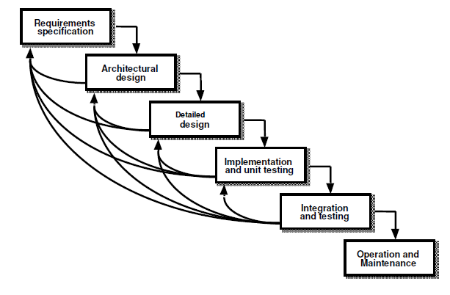

**Fig 1: Iterative software development life cycle**

**3.8.2 Use Case Diagram**

Use case diagram uses a combination of text and picture in order to give the visual representation of the system, and it captures the different functions to be performed by the system as well as the initiators of these functions but not how they will ultimately be implemented. A use case is a unified modeling language (UML) tool that describe the interactions and relationships of individual use cases and the users. A use case always describes three things: an actor that initiates an event, the event that triggers a use case, and the use case that performs the actions triggered by the event.

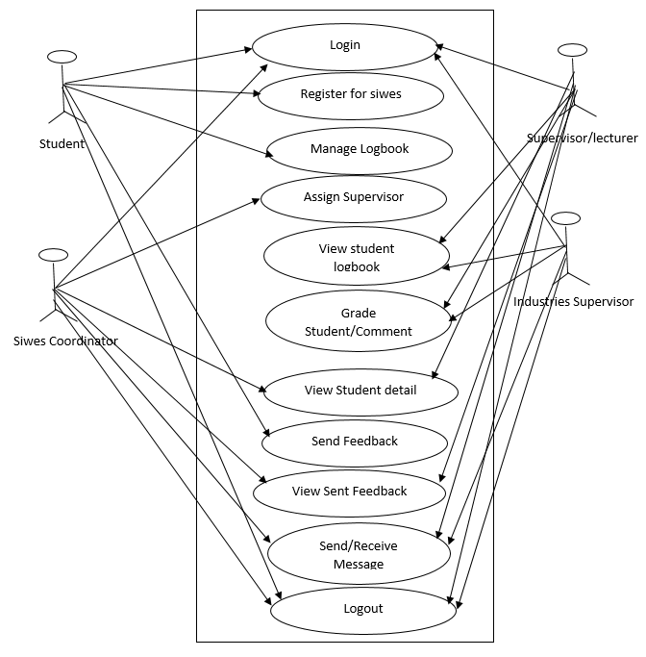

**Fig. 3.2 Use case Diagram**

# **3.8.3 Sequence Diagram**

A sequence diagram is an interaction diagram that can illustrate a succession of interactions between classes or object instances over time. That is, it shows a sequence of an interaction between the users and various classes/object of the system. Sequence diagrams are derived from use case analysis and are used in systems design to depict the interactions, relationships, and methods of the objects in the system including the messages that may be dispatched among them. Sequence diagrams address the dynamic view of a system.

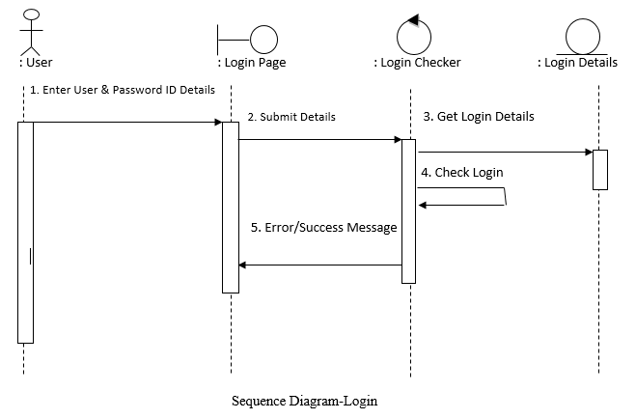

**Fig 3.3 Login sequence diagram**

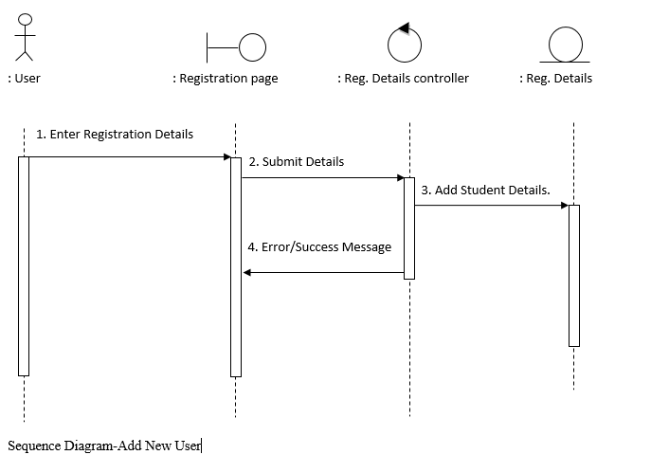

**Fig 3.4 Register new hostel occupant sequence diagram**

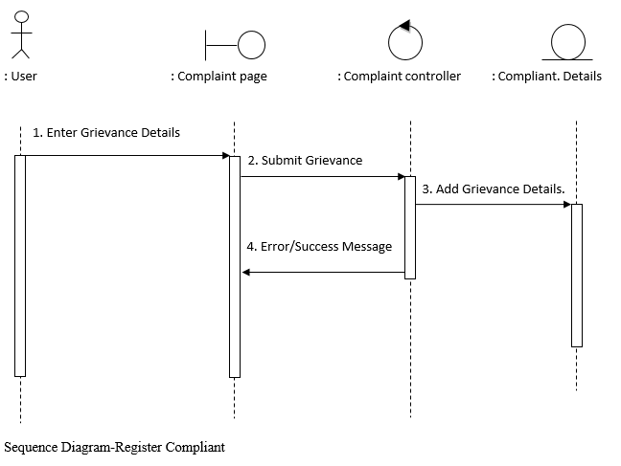

**Fig 3.5 Register complaint sequence diagram**

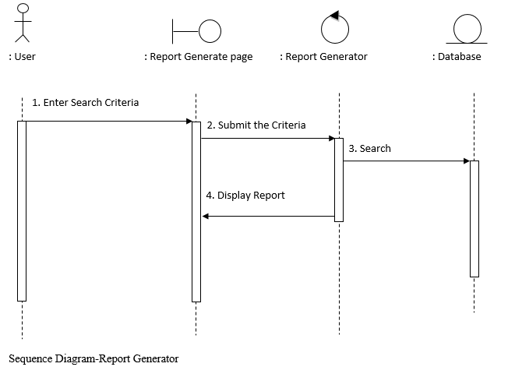

**Fig 3.6 Report generator sequence diagram**

**3.8.4. Class Diagram**

The main purpose of class diagrams is to build a static view of an application. It is the only diagram that is widely used for construction, and it can be mapped with object-oriented languages.

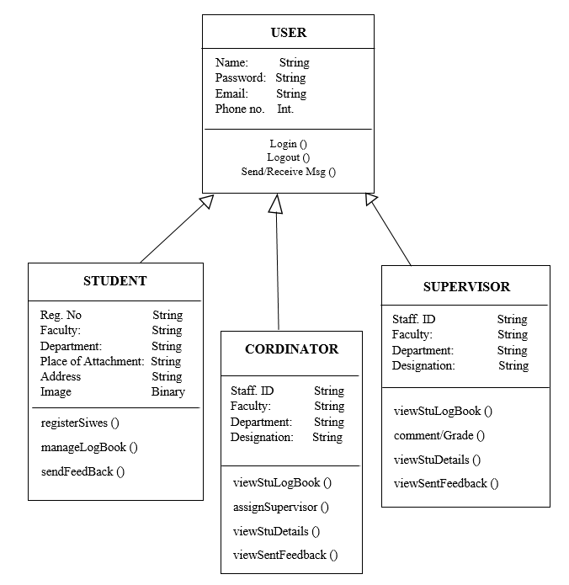

**Fig 3.7 System class diagram**

**3.9 SYSTEM SPECIFICATION**

Software requirement specification is a complete document which specifies all the required and proposed details. It also specifies all the functional and non-functional requirements with respect to each and specific user. It is also defining the characteristics and behavior of the user with respect to the proposed model.

**3.10 SYSTEM REQUIREMENT**

**3.10.1 Functional Requirements**

Functional requirement depicts the behavior of a system; these behaviors are related to the expectations from the intended or proposed software. They describe what the system has to do and sometimes it also specifies what the system will not do. They are also called product feature. All the functionalities expected from the proposed system are being stated.

1. The system’s users shall be able to log into the system.
2. The system’s users shall be able to logout of the system.
3. The students shall be able to sign up and create their account.
4. The system will provide a log book panel for the student to enter their day-to-day activities.
5. The system will allow supervision assessment by the lectures and industries based supervisors.
6. The system will allow the involves system’s users to communicate regularly.
7. The system will allow students to provide feedback regarding problems encountered.
8. The system will enable school and industries supervisor to explore earned experience by the student.

**3.10.2 Non Functional Requirement**

Non- functional requirements are mostly quality requirement that stipulate how well the software does what it has to do. Non-functional requirements are constraints on the services or functions offered by the system that define the overall qualities or attributes of the proposed system.

1. **User friendly:** The system should be graphical user interface (GUI) oriented thus it is easy and efficient to use by the users.
2. **Maintainability:** The system should be easy to maintain and accommodate changes.
3. **Security:** The system should request the username and password to avoid unauthorized user to log into the system.
4. **Responsiveness:** The system should respond to a user’s command immediately.
5. **Reliability:** The system should be reliable and dependable.

**3.11 DATABASE DESIGN**

The database management system (DBMS) used in implementing database design of the proposed system is MySQL which is relational database management system. It is accessed using a GUI i.e. graphical user interface provided by the phpMyadmin tool that allows the database to be administered through the web browser using a virtual server (XAMPP server). It chosen because of its simplicity and easy to operate in database design. Some of important tables are described below:

**The table below shows the structure of the Place of attachment table in the database.**

|  |  |  |  |
| --- | --- | --- | --- |
| S/N | Field Name | Data Type | Length |
| 1. | S/NO | Int | 11 |
| 2. | Student_reg_no | Varchar | 15 |
| 3. | Name_of_place | Varchar | 50 |
| 4 | Address_of_place | Varchar | 50 |
| 5 | Acceptance_Letter | Varchar | 30 |

**Table 3.0** Table Name: Place of Attachment table

|  |  |  |  |
| --- | --- | --- | --- |
| S/N | Field Name | Data Type | Length |
| 1. | S/NO | Int | 11 |
| 2. | Message | Varchar | 50 |
| 3. | Sender | Varchar | 50 |
| 4. | Send_Date | Varchar | 20 |

**Table 3.1 Table Name:** Notice Table

**The table below shows the structure of the Supervisor staff table in the database**

|  |  |  |  |
| --- | --- | --- | --- |
| S/N | Field Name | Data Type | Length |
| 1. | S/NO | Int | 11 |
| 2. | Fullname | Varchar | 50 |
| 3. | Staff_ID | Varchar | 50 |
| 4. | PhoneNumber | Varchar | 20 |
| 5 | Designation | Varchar | 30 |
| 6. | Email Address | Varchar | 30 |
| 7. | Password | Varchar | 50 |

**Table 3.2 Table Name:** Supervisor_Acc_Info

|  |  |  |  |
| --- | --- | --- | --- |
| S/N | Field Name | Data Type | Length |
| 1. | S/NO | Int |  |
| 2. | Fullname | Varchar | 50 |
| 3. | Reg. No | Varchar | 10 |
| 4. | Faculty | Varchar | 50 |
| 5. | Department | Varchar | 30 |
| 6. | Phone Number | Varchar | 50 |
| 7 | Email_address | Varchar | 20 |
| 8 | Date_of_Birth | Date |  |
| 9 | Image | LongBlob |  |

**The table below the structure of the student table in the database.**

**Table 3.3 Table Name:** Student_details

**CHAPTER FOUR**

**SYSTEM IMPLEMENTATION AND TESTING**

**4.1 INTRODUCTION**

In this chapter of the project, we have discussed and depict out, the programming tools used in system implementation and stages involved in implementing the proposed system. System requirement and testing were all discussed to ensure the system is working accurately and efficiently before it is put into operation.

**4.2 SYSTEM** **IMPLEMENTATION**

Implementation is the stage in the project where the theoretical design is turned into a working system and is giving confidence on the new system for the users that it will work efficiently and effectively. Implementation is said to be the conversion of the system requirement into an executable system (Aggarwal &Yogesh, 2007). In addition, system implementation involved the uses of system design and analysis result to construct system elements that meet the stakeholder requirements (Somerville, 2004). The implementation process begins with preparing a plan for the implementation of the system. According to this plan, the activities are to be carried out, discussions made regarding the equipment and resources and the additional equipment has to be acquired to implement the new proposed system. Implementation is one of the most important phase of software development life cycle (SDLC). The most critical factor in achieving a successful new system is giving the users confidence that the new system will work and be effective.

**4.2.1 Choice of Programming Language and IDE**

The proposed system (Online Siwes Management) is a web-based system designed to be executed over an online server. Therefore, the programming languages found suitable and appropriate to use in implementing the system are PHP, HTML, JavaScript and CSS. PHP is chosen to serve as server side scripting language used in query database for recording and retrieving the data in to application. Hypertext Mark-up Language (HTML) was also chosen being the standard mark-up language used for creating the web application easily. The Cascading Style Sheets (CSS) was used in order to improve the appearance on how the HTML elements will be display in the browser. It controls the layouts of the web pages.

Sublime was chosen as an integrated development environment (IDE) for the proposed project. Because sublime IDE was developed particularly, for developing web applications. It also provides the user with powerful debugging capabilities and enrich of layout editors that enable users to code easily. MySQL which is an open source relational database management system (RDBMS) was used in implementing the application database design, for data storage and processing.

**4.2.2 Description of the Coding**

The online Siwes Management System contain many web pages and each included page performed a specific function, all the pages are link together in order to enable users to performed their intent operation properly. The system has been tested locally using local server (xampp) application. Fortunately, all the web pages are found work perfectly as expected. Below are some of the pages that are tested and the results shown below.

**First Page:** The figure below is the index or home page, it is the first page to display, after the system is loaded and contains well labeled navigation link to link users to other part of system by clicking navigation links.

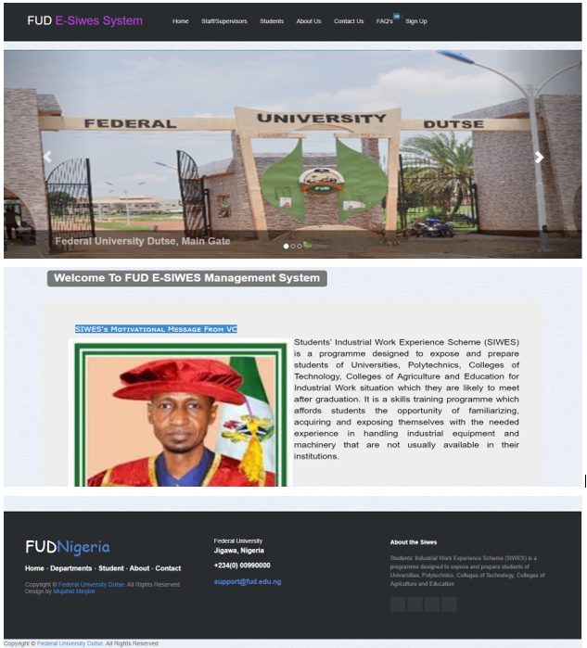

**Fig 4.1 index page**

**Login Page:** serves as the only door that any authorized user or the administrator will follow to access the records in the system. This depends on the user level of privilege. It requires username and password for access. It is designed to make the system more secured.

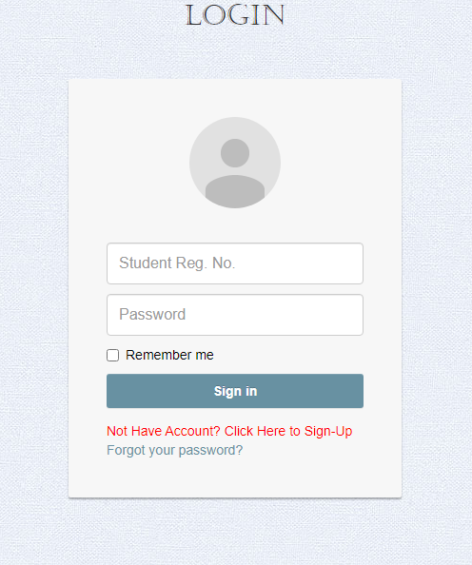

**Fig. 4.2 Login Page**

**Register Page:** Register page contains input field in which a student should fill in and submit for uploading his profile information.

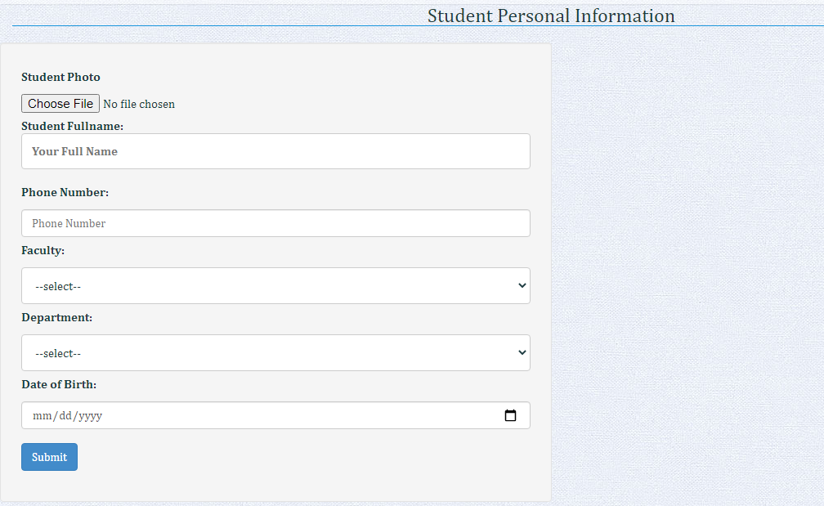

**Fig 4.3 Register Page**

**Student Dashboard page:** This is the student dashboard page that display upon successful authentication it contains many button and link to enable student to performed all his needful task over the system.

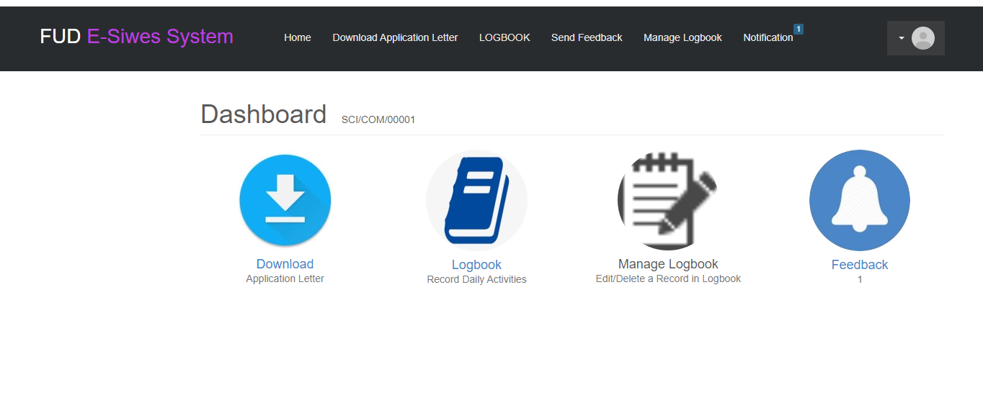

**Fig 4.4 student Dashboard**

**Supervisor Homepage:** it is a page that will display after successful login by the school supervisor, it contains some buttons that enable the supervisor to performed his required task over the system.

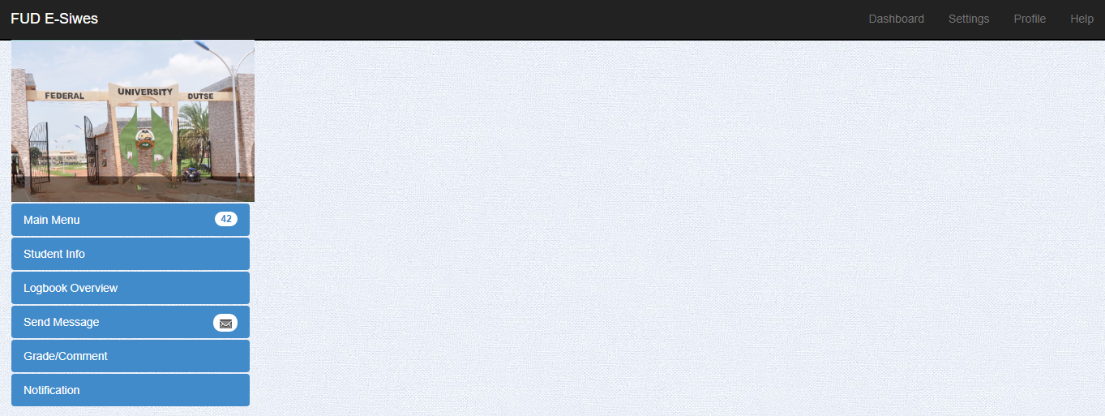

**Fig. 4.5 Supervisor Homepage**

**Logbook:** This page it serves as a logbook use by the student in filling and submitting their daily learned activities during the programme.

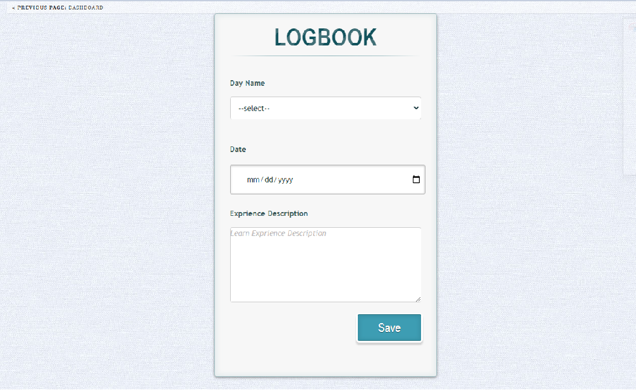

**Fig 4.6 Logbook**

**Industry based supervisor comment page:** This page is designed to enable the industry supervisor to view student logbook and make his weekly comment over it.

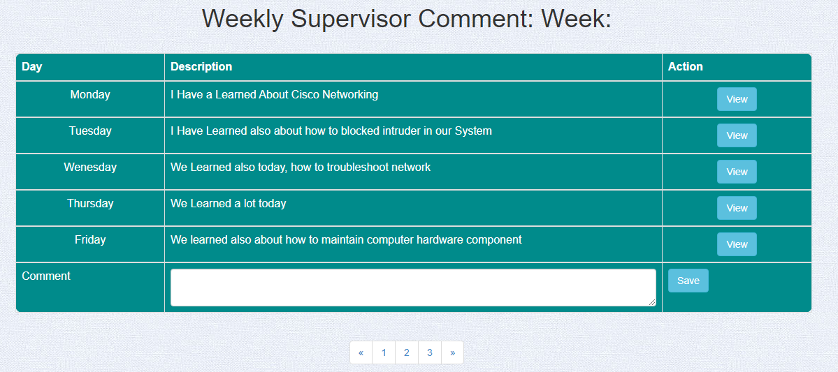

**Fig. 4.7** Industry Supervisor Weekly Comment Page

**Supervisor View Logbook Page:** This is the page that enable school supervisor to view weekly student record in logbook and comment made by his industry based-supervisor

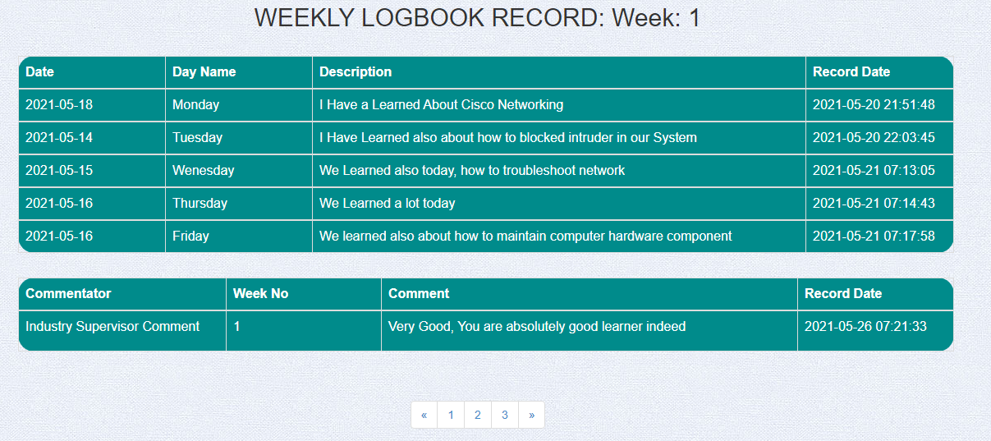

**Fig 4.8 Supervisor View Logbook**

**Student Detail Page:** This is the page designed to display the detail of the student such as his name, reg. no, email, place of attachment, address and his picture.

**4.3 TESTING**

System testing is the next stage or phase after system implementation. Testing refers to the process of executing a program with the intent of finding errors (Aggarwal &Yogesh, 2007). In addition, system testing refers to the verification and validation activities of the system to detect, locate and correct some errors found in the program. Software techniques include the process of executing a program or application with intent of finding software bugs, and verifying that software product is fit for use (<https://en.wikipedia.org/wiki/Software_testing>). The aim of this phase is to ensure that all application activities are working accurately and meet the objectives of the proposed project. In testing a system there are three level of testing which are unit, integration and system testing.

**4.3.1 Unit testing**

This is a software testing process used to validate all the software product module individually. The purpose of unit testing is to determine that each independent module is implemented correctly and works properly. The process involves taking each component or module, testing it in isolation from other part of software modules or components using a prepared test cases, and compare the generated output with the result determine or expect initially at the design and specification of the particular module.

**Table 4.1: Unit testing**

|  |  |  |
| --- | --- | --- |
| **Test case** | **Explanation** | **Result** |
| IsLogin() | To check whether login is successful if valid values are filled else unsuccessful login for invalid values. | Pass |
| ViewStudentDetails() | To retrieve the list of student in attachment and his details to the supervisors. | Pass |
| SendNotification () | To allows the supervisor and siwes coordinator to send notice to the students. | Pass |
| ViewNotification() | To enable student view notice, send by supervisor and siwes coordinator. | Pass |
| ViewLogBook() | To allow industry and school base supervisor to view student logbook record in order to make a comment. | Pass |
| AssignSupervisor() | To allow the siwes coordinator to assign a supervisors to students | Pass |
| Logout() | Allows user to logout of their account. | Pass |

**4.3.2 Integration Testing**

After testing each module independently, the different modules were then integrated one after the other to see that it meets the goal of the application. The splash and home screen were the first to be integrated and the output was examined. Other modules such as staff, admin, student module and login Activity, were later integrated. The inputs were tested to ensure run properly.

**Table 4.2: Integration testing**

|  |  |  |  |  |  |
| --- | --- | --- | --- | --- | --- |
| **Test Case ID** | **Test Case objective** | **Test Case Description** | **Input** | **Expected Output** | **Results** |
| 1 | Check the interface link between supervisor, coordinator and student with home page. | Click on student Tab. | Tab clicked.  Not clicked | To be directed to student login page.  Nothing happen | Pass  pass |
| 2 | Check the interface link between school supervisor homepage and other individual page for proper running and using the system by supervisor. | Click on needed link button, | Link button clicked.  Link button not clicked. | To be directed to intended page for carrying out the task.  Nothing happens. | Pass  Pass |
| 3 | Check the interface link between main student homepage and other pages of the student sections. | Click on any intended link button | Link button clicked.  Link button not clicked. | To be directed to other page for performing important task over the system  Nothing happens. | Pass.  Pass. |
| 4 | Check the interface link between student, supervisors and admin with logout link. | Click on the logout link from navigation menu. | Link button clicked.  Link button not clicked. | To be directed back to login page.  Nothing happens. | Pass.  Pass. |

### **4.3.3 System Testing:**

System testing is the third item in level of software testing strategy, that come into an action after integration testing has been conducted. It involves the process of integrating different components/module to create a complete or version of the system unit and then testing the integrated system as once. That is, system testing is conducted on this complete integrated proposed project system to evaluate the system's compliance with all its specified requirements which are stated in this project report. It has done to ensure that the system have met both the functional and non-functional requirements mentioned in the afore chapter precisely chapter three of the project software requirement and specification (SRS) document. In addition, system testing checks that different integrated software components are compatible, interact correctly and transfer the right data at the right time across their interfaces.

The final phase of the testing process, this test is conducted in order to ensure that the goal of the system met in terms of performance. It is a functionality test of the system; it tests the whole module as a single system. At this test phase, the usability, compatibility and dependability were tested. All the valid inputs were used to test the application and the generated output was examined with the expected output. In the event of any discrepancies between the system generated output and the expected output, the system was structurally tested through path testing to see where the error occurs and necessary measures were taken to correct the problem.

**4.4 SYSTEM SPECIFICATION**

The system specifications show the hardware and software requirements needed to run the Application.

**Table 4.3:** **Hardware requirements**

|  |  |  |
| --- | --- | --- |
| **S/N** | **Hardware** | **Minimum System Requirement** |
| 1 | Processor | 1 GHZ processor speed |
| 2 | Memory | 128 MB |
| 3 | Disk space | 800MB |

## **Table 4.4: Software Requirements**

|  |  |  |
| --- | --- | --- |
| **S/N** | **Software** | **Minimum System Requirement** |
| 1 | Operating System | Windows, Linux Mac OS etc. |
| 2 | Random access memory(RAM) | 2GB RAM minimum, 4GB RAM recommended |
| 3 | Database Management System | MySQL |

**CHAPTER FIVE**

**SUMMARY, CONCLUSION AND RECOMMENDATION**

# **5.1 INTRODUCTION**

Thischapter provide a brief summary and conclusion of the project. It also presents some of recommendations as far the project is concerned, based on the analysis conducted and the literature reviewed about the project.

# **5.2 SUMMARY**

It can be observed that the advent of computer, have influenced in every field of human life aspect. So this project has tried to portray the absolute importance of computer application in providing a streamline operation in performance SIWES management system and keeping records of students. The automated system reduces the workload of the department staffs most especially siwes coordinator and student, saves time and increases efficiency of the process. Thus, difficulties encountered with the current manual process are overcome.

In general, this project has been categorized into five chapters. The first chapter introduces the background, aim, objectives, scope and limitations of the project. Second chapter explained a literature review on the related project topic. The third chapter contained system analysis and design to identify weaknesses of the current system. Programming language used to achieve the aim of the project, system requirements and operational procedure of the designed system are also discussed in fourth chapter. Finally, this chapter (five) contains summary, conclusion and some of recommendation on the work done in this project.

# **5.3 CONCLUSION**

In conclusion, the proposed online SIWES management system will offer greater opportunity for the University due effectiveness and efficiency of the proposed system. As mentioned the objectives in previous chapter precisely chapter one, some of the objectives of this project were not actualized due to some limitation. But this provide room for further improvement in the future. The online SIWES management system was developed using HTML, PHP and MySQL. SIWES system was able to manage siwes process across the faculty of science in Federal University Dutse (FUD), and it eliminated the weakness of the manual process such as slow, clumsy and stressful.

In addition, the developed system is capable of storing and processing student logbook with high speed and accuracy, and presenting output in certain required format. Other qualities of this system include reduction in cost of travelling, elimination of stress for both students and involve staff, reduction of paper works and reliability.

**5.4 RECOMMENDATION**

The following recommendations were offered based on the literature reviewed and the analysis conducted:

1. The need for computerization and generating SIWES management system should be accepted and adequately implemented because of its effect to the student and staff involved.
2. It is recommended that the application should be implement especially in University as it will be of great impact to the development of the University.
3. All the department in the University are currently running manual system of SIWES programme, and it is recommended to automate the activities of the programme so as to integrate automate the entire process.
4. It is recommended to continue improving the study by adding modules that overcome the limitation of this particular proposed project.

**REFERENCES**

Adetiba, E., Egunjobi, V.O., Matthews, V.O. & Olajide, A. T (2012). Development of e-SIWES Portal: A Web based Platform for Student Industrial Work Experience Scheme (SIWES) Management. International Journal of Applied Information Systems (IJAIS), Foundation of Computer ScienceFCS,3(8):10-17.

Mafe, O.A.T. (2010). Effectiveness of SIWES with Respect to Chemical Engineering. Available on http://www.nsche.org.ng/cms/publications_cms/uploads/lecture_nsche_engr_mafe.pd. Assessed on December, 27, 2015.

Oyeniyi, PhD (2012) Students’ Industrial Work Experience Scheme (SIWES) and the Incidence of Occupational Misfitin Nigeria

Online SIWES Management Information Management System A Case Study of Akwa-Ibom State Polythicnics, Ikot Osurua. A project submitted in partial fulfillment of the requirements for the award of Bachelor of Science (B.Sc.) in Computer Science.

Hewlett M. (1993). The internet in education column: special issue+. “Internet world”, 6 (10).

Tarlor M. (1980). Education and training achieve and records manager in the Africa. Ibadan, Nigeria: Odun publishing company.

Impact of ICT on Records Management in an Organization https//www.ukessay.com

Hafiz and H. Muhammad (2017) SIWES Management system: Web Technology Approach Case study faculty of computer science and information technology.

Online SIWES Management Information Management System A Case Study of Akwa-Ibom State Polythicnics, Ikot Osurua.

Nse, J. (2012). Evaluation of Student Industrial Work Experience Scheme (SIWES) in Library School: The Federal Polytechnic Nekede Experience. Library Philosophy and Practice (e-journal), Paper728.

Availableonhttp://digitalcommons.unl.edu/libphilprac/728

Gary B. Shelly & Misty E. Vermaat (2011) Discovering Computers Fundamental.

Vossen, W. S. (2002), Contemporary issue in Information Technology, Welly and Son’s Publishers, Lagos.

Detail about system analysis and design available at http:// www.study.com/lesson/

Concept of complaint at http//[www.wikipedia.com](http://www.wikipedia.com)

Aggarwal &Yogesh, (2007), Software Engineering